
Workforce Committee (WFC) – 26.7.23
Agenda item:  Presented by:  Prepared by:  Date prepared:  Subject / title: | 2.12  Sharon McNally – Chief Nurse and Deputy CE  Sarah Webb – Deputy Chief Nurse  16.1.2023  Report on Nursing and Care Staff Levels for December 2022– Hard Truths Report
Purpose: | Approval |  | Decision |  |  | Information |  | x | Assurance |  | x
Key issues:  please don’t expand this cell; additional information should be included in the main body of the report | The overall fill rates for December were 89.7%. RN fill rate decreasing by 5.5% to 85.2% and care staff fill rates also decreased by 5.4% to 89.7%in line with additional escalation areas being opened and increased sickness from Covid and flu like symptoms
Recommendation: | The committee is asked to note the information within this report.
Trust strategic objectives: please indicate which of the five Ps is relevant to the subject of the report |   Patients |   People |  |   Performance |  |  |   Places |  |  |   Pounds
 | x | x |  | x |  |  |  |  |  | x
Previously considered by: | NA
Risk / links with the BAF: | BAF: 2.1 Workforce capacity  All Divisions have both recruitment and retention on their risk registers
Legislation, regulatory, equality, diversity and dignity implications: | NHS England and CQC letter to NHSFT CEOs (31.3.14): Hard Truths Commitment regarding publishing of staffing data.  NHS Improvement letter: 22.4.16  NHS Improvement letter re CHPPD: 29/6/18
Appendices: | Appendix 1: Registered fill rates by month against adjusted standard planned template. RAG rated.  Appendix 2a: Ward staffing exception reports.



There was a downward trend in average fill rates in December; with the overall fill rates for December were 89.7%. RN fill rate decreasing by 5.5% to 85.2% and care staff fill rates also decreased by 5.4% to 89.7%. Nightingale ward continues to be open as part of winter escalation plans and additional surge areas were staffed to support flow in December such as PACU and ADSU.
AAU is an emerging risk with a 39% Band 5 vacancy rate. The ward is being supported and prioritised for new starters from International pipeline and as well a number of other measures to ensure fill rates and skill mix meet demand and acuity.
ED fill reduced in December due to vacancies and increased sickness. Recruitment activity continues. Overall vacancy in ED is 12% (10.95WTE) Across nursing there are 23 new international nurses staring in January with a further 48 before the end of March. Details on pipeline for 2023/24 will be provided in next report.
Overall Care Hours Per Patient Day (CHPPD) was 6.8 for December. The Model Hospital data for October 2022 shows the Trust with a CHPPD of 6.8 against the national median of 7.9. CPPD has fallen in line with additional escalation ward Nightingale opening.

Nursing and midwifery fill rate

ED Fill rate

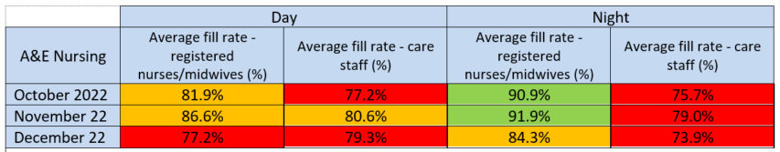

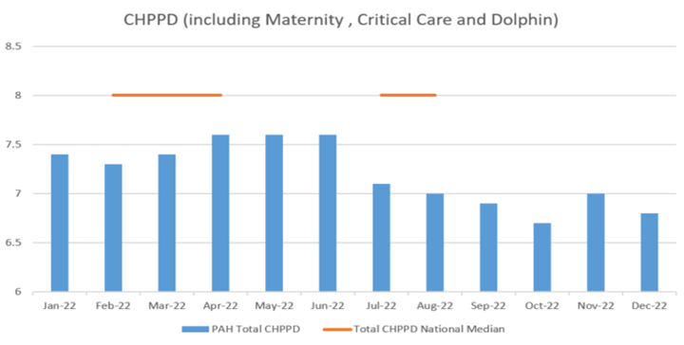

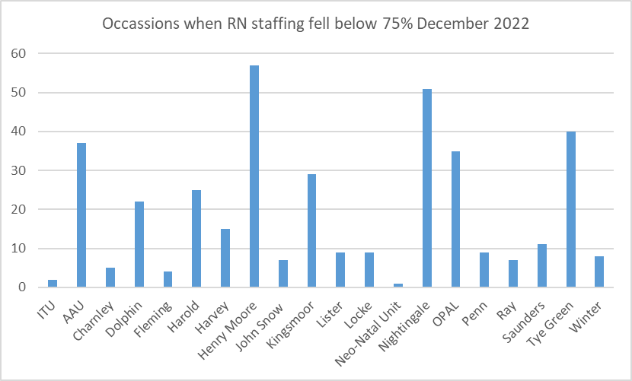
The number of occasions/shifts where the reported fill rate has fallen below 75% across the wards (excluding Maternity) increased to 383 (↑262) against November. If a nursing red flag event occurs for number of staff on duty to meet the care needs of patients, staff escalate the situation and if appropriate complete a Datix.
The trend in reports completed in relation to nursing and midwifery staffing is included below and shows that the number of incidents recorded had increased in month to 75 (↑31),
Tye Green raised 14, AAU 11, Kingsmoor 7 and A&E 6 Datix reports in relation to staffing levels where RN staffing has fallen below 75% across the wards (excluding Maternity) increased to 383 (↑262) against November. If a nursing red flag event occurs for number of staff on duty to meet the care needs of patients, staff escalate the situation and if appropriate complete a Datix.
Nightingale, Henry Moore, Tye Green and Dolphin reported average fill rates below 75% for RN against the standard planned template during December. This is the fourth consecutive month overall fill rates have been below 75% for Tye Green. Details on the impact on care can be found in below
Redeployment of staff continues to be undertaken to support SafeCare as part of the daily huddles. In December staff were moved from elective surgical wards (JSU and HMU) followed by Opal and Fleming both wards that have very low vacancies or are over establishment. Highest net receivers of staff were Nightingale (winter escalation), Penn and Kingsmoor. Work will commence in February on creating buddy wards to minimise impact on staff of having to move to an unfamiliar area.

Redeployment
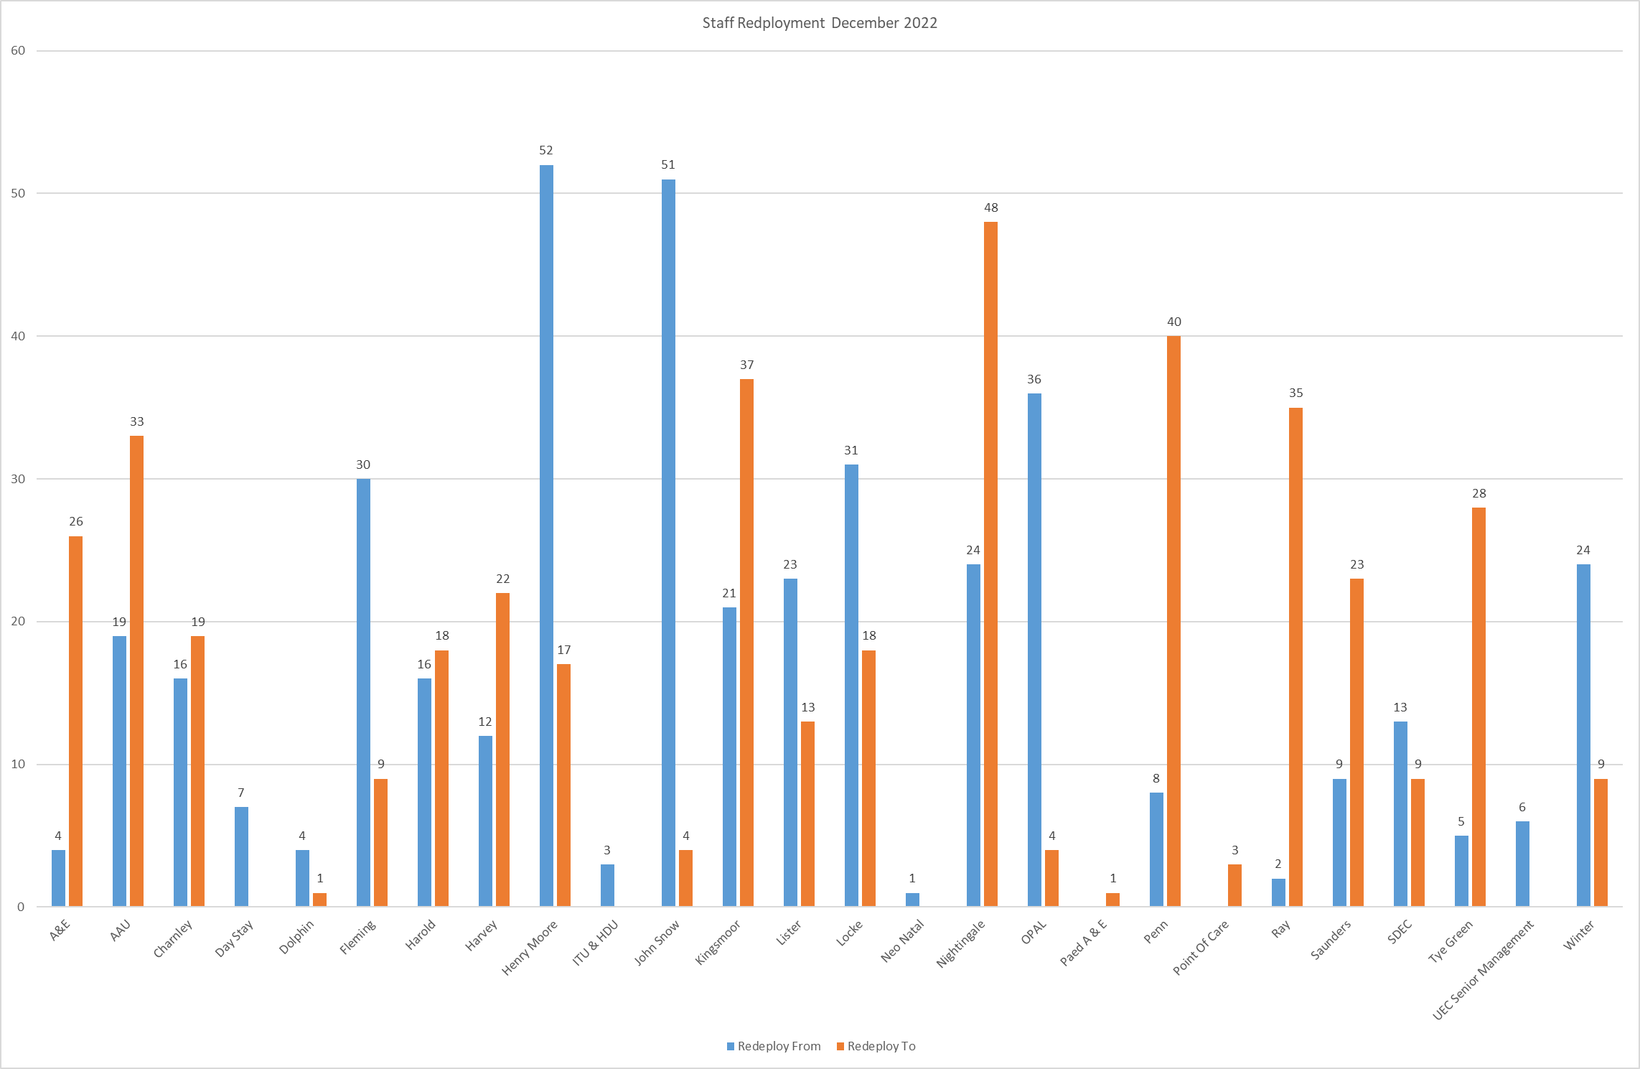

Appendix.1. Ward level data: fill rates December 2022. (Adjusted Standard Planned Ward Demand)

 | Day |  | Night |  | % RN overall fill rate | % overall HCSW fill rate | % Overall fill rate
Ward name | Average fill rate - registered nurses/midwives (%) | Average fill rate - care staff (%) | Average fill rate - registered nurses/midwives (%) | Average fill rate - care staff (%) | % RN overall fill rate | % overall HCSW fill rate | % Overall fill rate
ITU & HDU | 95.3% | 49.0% | 94.8% | 54.1% | 95.1% | 51.5% | 87.8%
Saunders Unit | 84.8% | 106.7% | 82.0% | 136.5% | 83.6% | 118.0% | 95.9%
Nightingale | 70.4% | 75.2% | 68.9% | 95.1% | 69.7% | 84.7% | 75.7%
Penn Ward | 83.7% | 108.0% | 85.5% | 152.3% | 84.5% | 124.8% | 98.9%
Henry Moore Ward | 69.8% | 50.1% | 65.6% | 43.3% | 67.8% | 46.9% | 59.4%
Harvey Ward | 77.4% | 105.0% | 94.8% | 112.4% | 84.5% | 108.5% | 93.2%
John Snow Ward | 97.5% | 40.9% | 91.9% | 49.8% | 94.8% | 43.7% | 72.7%
Charnley Ward | 83.4% | 106.5% | 85.8% | 107.7% | 84.5% | 107.0% | 91.0%
AAU | 75.5% | 135.4% | 76.5% | 125.7% | 75.9% | 130.8% | 87.7%
Harold Ward | 69.1% | 65.6% | 91.4% | 114.2% | 78.2% | 85.4% | 80.6%
Kingsmoor General | 64.4% | 110.7% | 90.4% | 120.5% | 74.3% | 115.4% | 89.6%
Lister Ward | 82.8% | 98.3% | 100.2% | 123.5% | 90.2% | 110.4% | 98.2%
Locke Ward | 89.9% | 84.9% | 79.3% | 113.3% | 84.8% | 98.5% | 89.9%
Ray Ward | 83.0% | 85.9% | 92.7% | 133.4% | 87.1% | 103.9% | 93.1%
Tye Green Ward | 62.4% | 94.1% | 72.3% | 116.6% | 66.7% | 103.2% | 80.9%
OPAL | 88.3% | 92.8% | 74.4% | 101.6% | 81.6% | 97.0% | 87.8%
Winter Ward | 81.1% | 92.1% | 88.0% | 113.6% | 84.0% | 102.4% | 91.3%
Fleming Ward | 81.8% | 110.8% | 91.3% | 105.2% | 85.8% | 108.2% | 92.7%
Neo-Natal Unit | 104.4% | 83.9% | 95.6% | 112.9% | 100.0% | 98.4% | 99.7%
Dolphin Ward | 72.4% | 96.7% | 76.2% | 88.9% | 74.1% | 94.1% | 79.1%
Total | 70.1% | 90.2% | 85.6% | 109.0% | 76.6% | 98.5% | 83.4%

Appendix.2. Ward staffing exception reports for 4 areas where fill was below 75% NB In graphs below bars = staff on shift; blue line = staffing required based on acuity and dependency recorded twice a day and the green line = demand template based on establishment review.

Report from the Associate Director of Nursing for the Division
Ward | Analysis of gaps |  |  |  | Impact on Quality / outcomes |  |  |  |  | Actions in place
This is the fourth consecutive month that Tye Green overall RN fill rate has been below 75% | RN overall Fill: 66.7%  HCSW Overall Fill: 103.2%  Overall Fill: 80.9% |  |  |  | Quality metrics remain static in month – risk recognised regarding pressure area care.  Positive feedback from patients from FFT |  |  |  |  | Ward Manager worked within the numbers  Practice Development Team support that is not captured in Safecare- working alongside staff in their preceptorship period.  Support from Out Patients (going forward captured in Safecare).  Regular Safety Huddles to review patient acuity and dependency and assign staff accordingly.  Cohorting of patients based on enhanced care need to mitigate risk of falls and pressure injuries.  Matron support in relieving staff for breaks and delivering patient care.
Quality Metric | PU | Falls | Staffing Datix | SIs |  | Drug Errors |  | Complaints | PALS
Number in month | 10 | 1 | 14 | 0 |  | 0 |  | 0 | 1
Required vs Actual Day |  |  |  |  |  |  | Required vs Actual Day
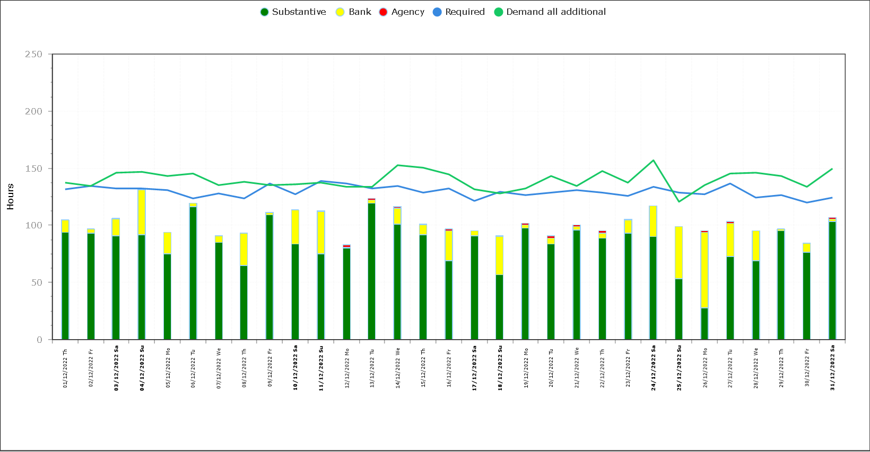 |  |  |  |  |  |  | 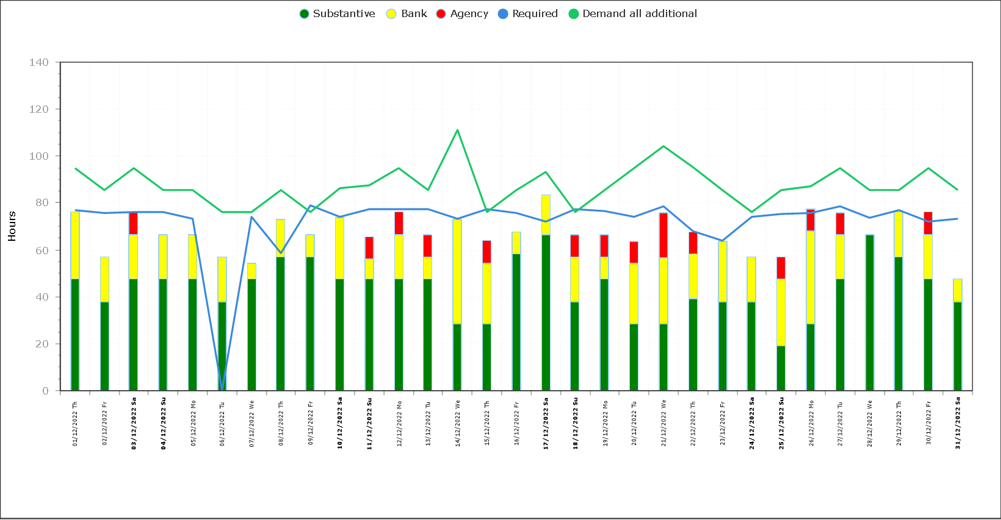

Report from the Associate Director of Nursing for the Division
Ward | Analysis of gaps |  |  |  | Impact on Quality / outcomes |  |  |  |  | Actions in place
Henry Moore | Fill rates below template staffing: RN fill 67.8% HCSW Fill =46.9% Overall fill 59.4%. |  |  |  | Nil |  |  |  |  | A review of bed capacity and staffing is being undertaken by the surgical Division  Graphs below demonstrate the actual number of staff on shift (bars) was ABOVE that required by the acuity and dependency of patients including numbers of patients during December (blue line) The green line is the template numbers on shift (the plan) Fill rates are calculated on blue line minus green line.
Quality Metric | PU | Falls | Staffing Datix | SIs |  | Drug Errors |  | Complaints | PALS
Number in month | 0 | 0 | 0 | 0 |  | 0 |  | 0 | 0
Required vs Actual Day |  |  |  |  |  |  | Required vs Actual Day
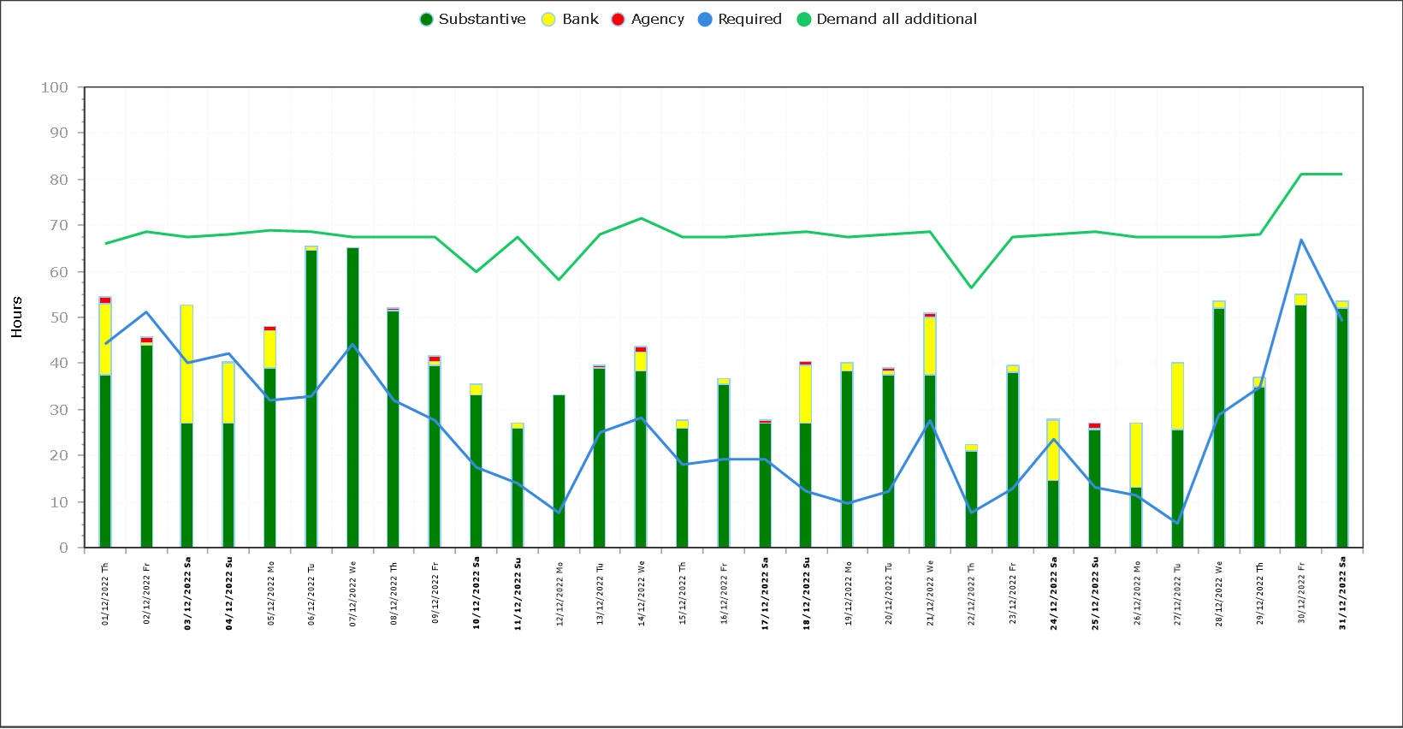 |  |  |  |  |  |  | 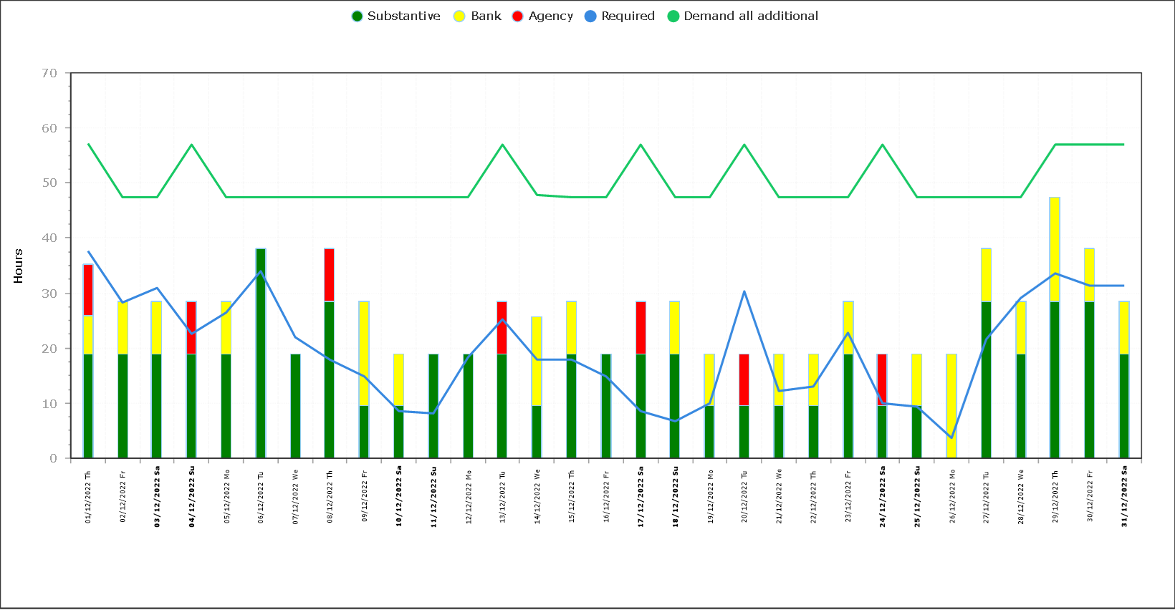

Report from the Associate Director of Nursing for the Division
Ward | Analysis of gaps |  |  |  | Impact on Quality / outcomes |  |  |  |  | Actions in place
Nightingale | RN Fill = 69.7%  HCSW fill = 84.7%  Overall fill = 75.7% |  |  |  | Quality outcomes remain in line with expected with good mitigation to meet patient needs. |  |  |  |  | Ward Manager worked on the ward which is not reflected on Safecare  Support from Outpatients nursing  Practice Development team support  Regular patient safety huddles to support prioritising patient care needs and utilisation of staff.  Daily matron support and oversight.
Quality Metric | PU | Falls | Staffing Datix | SIs |  | Drug Errors |  | Complaints | PALS
Number in month | 2 | 4 | 3 | 0 |  | 0 |  | 1 | 2
Required vs Actual Day |  |  |  |  |  |  | Required vs Actual Day
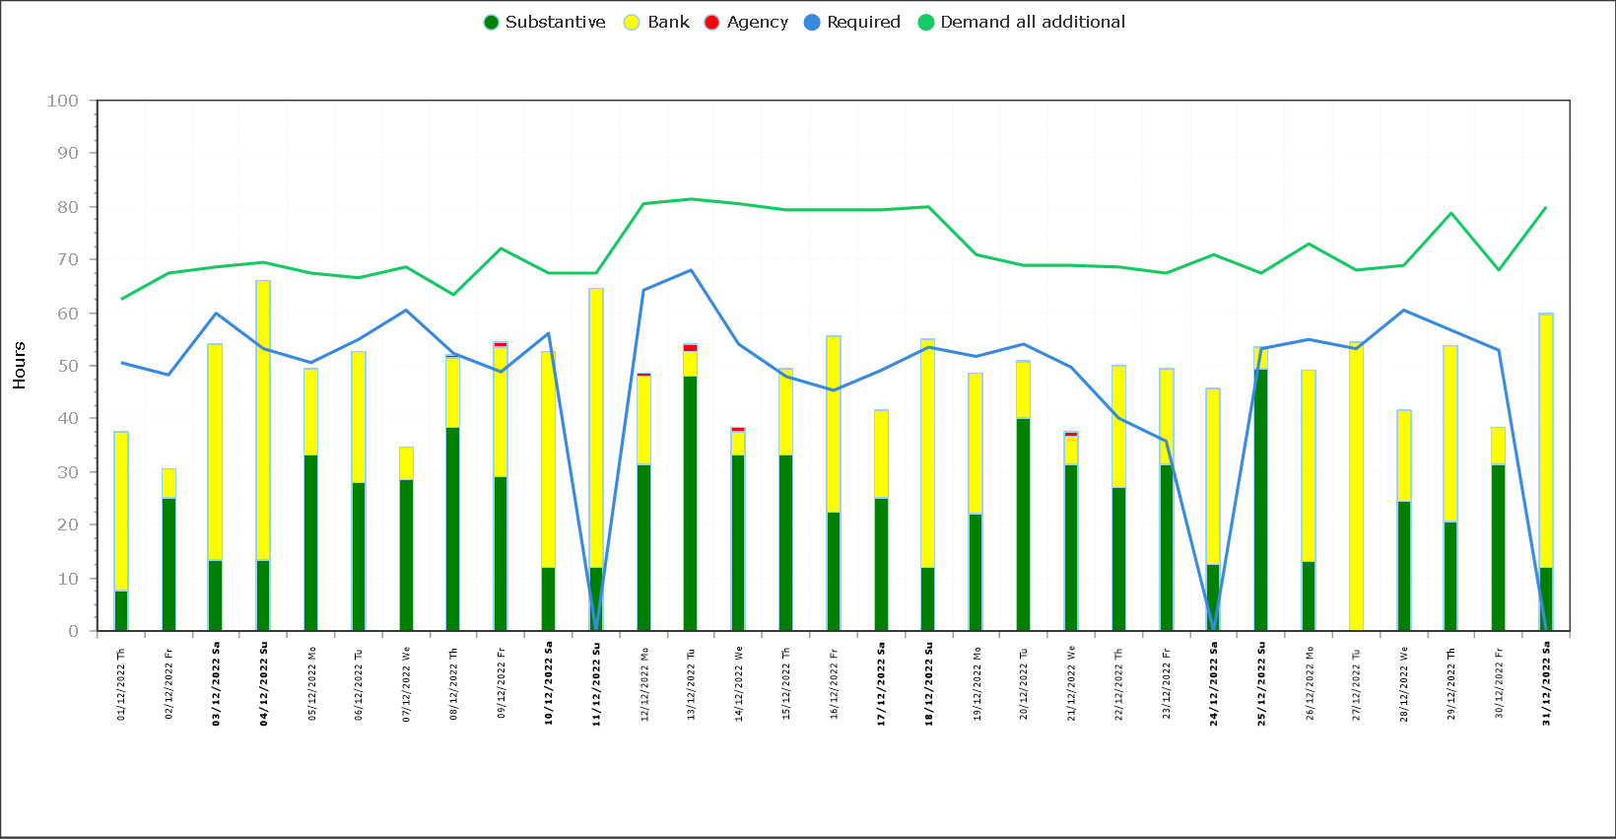 |  |  |  |  |  |  | 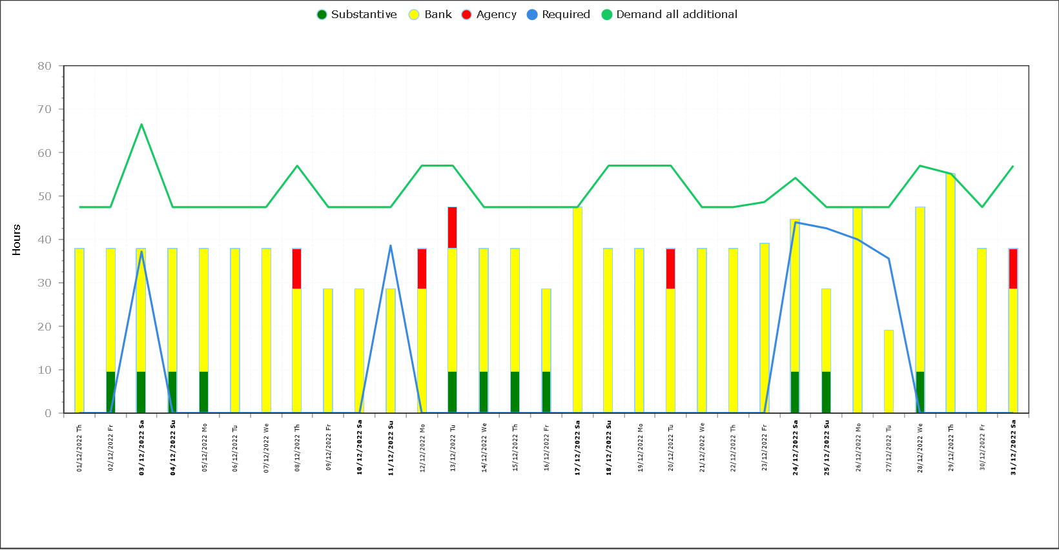

Report from the Associate Director of Nursing for the HCG
Ward | Analysis of gaps |  |  |  | Impact on Quality / outcomes |  |  |  |  | Actions in place
Dolphin | RN overall fill: 74.1% HCSW fill: 94.1% Overall 79.1% |  |  |  | Nil |  |  |  |  | Nil Required
Quality Metric | PU | Falls | Staffing Datix | SIs |  | Drug Errors |  | Complaints | PALS | Nil Required
Number in month | 0 | 0 | 0 | 0 |  | 0 |  | 0 | 0 | Nil Required
Required vs Actual Day |  |  |  |  |  |  | Required vs Actual Day
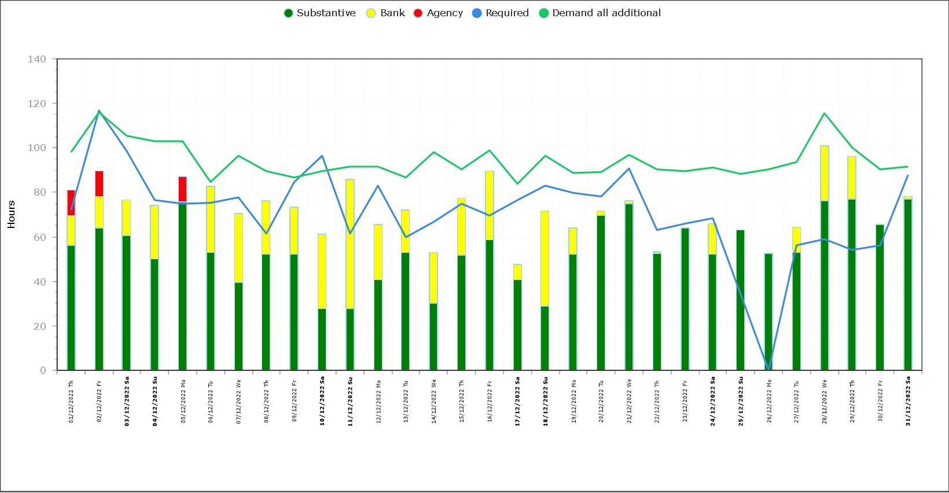 |  |  |  |  |  |  | 