Agenda item:  Presented by:  Prepared by:  Date prepared:  Subject / title: | Giuseppe Labriola – Deputy Chief Nurse  David Dellow – Safe Staffing Lead and Giuseppe Labriola – Deputy Chief Nurse  20.01.2025  Report on Nursing and Midwifery staff levels for December 2024.
Purpose: | Approval |  | Decision |  |  | Information |  | x | Assurance |  | x
Key issues: | There has been a sustained overall registered fill of > 95%.  No wards achieved < 75% overall fill rate in month. The increase in overall fill rates is multifaced with a combination of enhanced care needs and supernumerary time driving this. The results of the full year establishment review (which underpins the rota templates) is due to report to Board in February 2025.
Recommendation: | The committee are asked to note the information within this report.
Trust strategic objectives: |   Patients |   People |  |   Performance |  |  |   Places |  |  |   Pounds
Trust strategic objectives: | x | x |  | x |  |  |  |  |  | x
Previously considered by: | NA
Risk / links with the BAF: | BAF: 2.1 Workforce capacity
Legislation, regulatory, equality, diversity and dignity implications: | NHS England and CQC letter to NHSFT CEOs (31.3.14): Hard Truths Commitment regarding publishing of staffing data.  NHS Improvement letter: 22.4.16  NHS Improvement letter re CHPPD: 29/6/18
Appendices: | Appendix 1: Ward and divisional fill rates by month against adjusted standard planned template.  Appendix 2: Ward and divisional CHPPD data  Appendix 3: Nursing red flags  Appendix 4: Nursing quality indicators

1.0 Introduction
This paper illustrates how PAHT’s nursing and midwifery staffing has been deployed for the month of December 2024. It evidences how planned staffing has been successfully achieved and how this is supported by nursing and midwifery recruitment and deployment.

2.0 Background
The National Quality Board (NQB 2016) recommend that monthly, actual staffing data is compared with expected staffing and reviewed alongside quality of care, patient safety, and patient and staff experience data. The Trust is committed to ensuring that improvements are learned from and celebrated, and areas of emerging concern are identified and addressed promptly. This paper will identify safe staffing and actions taken in December 2024. The following sections identify the processes in place to demonstrate that the Trust proactively manages nursing and midwifery staffing to support patient safety.
3.0 Inpatient wards fill rate
The Trust’s safer staffing submission has been submitted to NHS Digital for December 2024 within the data submission deadline. Table 1 shows the summary of the overall fill rate for this month. Table 2 shows a summary of overall fill rate percentages for a rolling 12-month period.
Appendix 1 illustrates a ward-by-ward breakdown for this period.
3.1 Wards with < 75% average fill rate
No wards that had an overall fill rate of < 75%:
3.2 Wards with > 100% average fill rate
Henry Moore Ward has an increased fill rate due to fluctuating capacity and opening of additional surgical beds and a Level 1 area for post-operative patients, the Level 1 bay is staffed by ITU and the staffing is reflected in their numbers. Therefore, the additional staff are reflective of the required workforce to meet the activity demands.
The impact of staffing requirements for patients requiring enhanced care is shown in the number of wards which continue to have greater than 100% fillrate, this is demonstrated in wards such as Penn, Saunders, AAU and Charnley night fill rate for Healthcare support workers (HCSWs). The fill rate is based against the standard ward template
Greater than 100% fill rate for Registered Nurse (RN) shifts are attributable to Registered Mental Health (RMN) and 1:1 requirements or supporting the induction of newly qualified/registered RNs.
The Trust continues to utilise NHS Professionals and agency to mitigate vacant shifts. Additional control measures continue to be in place regarding the creation of additional duties. Furthermore, our senior nurses and midwives are also supporting individual areas when required. SafeCare data continues to be collected three times a day to enhance staffing governance across the organisation.
Further detail can be found in Appendix 1

Table 1. Overall fill rate
Average day fill rate - registered nurses/midwives | Average day fill rate - care staff | Average night fill rate - registered nurses/midwives | Average night fill rate - care staff | % Registered overall fill rate | % HCSW overall fill rate | % Overall fill rate
94.4% | 102.2% | 99.2% | 129.7% | 96.5% | 114.5% | 102.4%

Table 2. Inpatient fill rate including Maternity Wards Trend

4.0 Care Hours Per Patient Day (CHPPD)

CHPPD allows comparison of a ward’s CHPPD figure with that of other wards in the hospital, or with similar wards in other hospitals. It can be used to look at variation between similar wards to ensure the right staff are being used in the right way and in the right numbers.
The hours worked during day and night shifts by registered nurses and midwives and healthcare assistants are added together. This figure is then divided by the number of patients at midnight, this then gives the total CHPPD
By itself, the CHPPD does not reflect the total amount of care provided on a ward nor does it directly show whether care is safe, effective or responsive. It should therefore be considered alongside measures of quality and safety.
Table 3. Overall Care Hours Per Patient Day (CHPPD) December 2024

Registered CHPPD | Unregistered CHPPD | Total CHPPD
4.8 | 2.7 | 7.5

The Model Hospital data for October 2024 shows the Trust with a CHPPD of 7.6 against the national median of 8.4. Table 4 also shows the Trusts total CHPPD against our peers (East and North Hertfordshire NHS Trust and West Hertfordshire Teaching Hospitals NHS Trust)
Appendix 2 shows the individual ward and divisional CHPPD for December 2024
Table 4. CHPPD Trend

5.0 Quality Indicators

5.1 Nursing Red Flags
Nursing red flags prompt an immediate response by the registered nurse in charge of the ward. The response may include allocating additional nursing staff to the ward or other appropriate responses. Appendix 3 details the NICE (2014) definition of Nursing Red Flags and the number of occasions when registered staffing fell below 75% of the standard template and trend. Currently, this information cannot be monitored for all nursing red flags on the DATIX system and a system has been implemented to capture these in SafeCare.
5.2 Quality indicators (Falls, pressure ulcers and complaints, PALS and compliments)

Nursing quality indicators have been reviewed and there is no correlation between these, fill rates or red flags which are a cause of concern. A review of quality indicators can be found in Appendix 4

6.0 Conclusion
The Trust continues to achieve a sustained overall registered fill of > 95%. The increase in overall fill rates is multifaced with a combination of enhanced care needs and supernumerary time driving this. The results of the full year establishment review, which underpins the ward establishment, is due to report to Board in February 2025.

7.0 Recommendation
The committee are asked to note the information in this report to provide assurance on the daily mitigation of nursing and midwifery staffing.

Appendix 1: Ward level data and narrative: fill rates December 2024 (Adjusted Standard Planned Ward Demand)
>100% | 95 – 100% | 75-95% | <75%

 | Day |  | Night
Ward name | Average fill rate - registered nurses/midwives (%) | Average fill rate - care staff (%) | Average fill rate - registered nurses/midwives (%) | Average fill rate - care staff (%) | % Registered overall fill rate | % HCSW overall fill rate | % Overall fill rate
Harvey | 82.1% | 134.8% | 100.1% | 128.6% | 89.4% | 131.9% | 104.8%
Henry Moore | 140.1% | 128.5% | 181.1% | 153.3% | 156.5% | 140.3% | 149.5%
ITU & HDU | 93.4% | 67.0% | 98.0% | 116.1% | 95.7% | 91.6% | 95.3%
John Snow | 105.5% | 41.9% | 98.5% | 66.6% | 102.2% | 49.7% | 79.5%
Penn | 110.2% | 119.8% | 116.9% | 204.3% | 113.0% | 151.8% | 126.9%
Saunders | 94.0% | 123.4% | 127.2% | 198.4% | 106.5% | 151.8% | 123.5%
Surgery Total | 100.6% | 108.4% | 112.4% | 155.0% | 105.9% | 127.7% | 112.5%
Fleming | 85.9% | 107.0% | 98.0% | 143.1% | 91.0% | 124.3% | 101.2%
Harold | 90.0% | 93.5% | 99.4% | 116.4% | 94.2% | 104.4% | 97.4%
Kingsmoor | 85.5% | 116.9% | 100.9% | 146.8% | 91.3% | 131.2% | 106.2%
Lister | 101.2% | 98.4% | 109.7% | 112.0% | 104.8% | 104.9% | 104.8%
Locke | 94.6% | 110.7% | 100.2% | 129.9% | 97.0% | 119.9% | 106.1%
Nightingale | 111.6% | 92.1% | 101.6% | 212.7% | 106.8% | 130.0% | 116.8%
Opal | 103.3% | 101.8% | 93.6% | 111.0% | 98.7% | 106.2% | 101.7%
Ray | 93.9% | 96.3% | 100.0% | 159.1% | 96.5% | 120.1% | 104.9%
Tye Green | 93.2% | 89.8% | 95.6% | 138.9% | 94.2% | 109.8% | 100.3%
Winter | 92.3% | 100.9% | 100.8% | 109.6% | 95.9% | 105.0% | 99.5%
Medicine Total | 93.4% | 100.4% | 99.9% | 132.0% | 96.2% | 114.6% | 103.0%
AAU | 84.8% | 140.6% | 91.3% | 165.6% | 87.7% | 152.5% | 101.3%
Charnley | 99.0% | 140.2% | 93.2% | 180.4% | 96.2% | 159.4% | 114.3%
UEC Total | 90.2% | 140.4% | 92.1% | 173.0% | 91.1% | 156.0% | 106.8%
Birthing | 101.1% | 97.4% | 70.4% | 77.3% | 86.4% | 87.8% | 86.9%
Chamberlen | 98.6% | 66.1% | 95.4% | 71.0% | 97.1% | 68.4% | 89.9%
Dolphin | 84.0% | 85.2% | 87.0% | 102.2% | 85.3% | 90.9% | 86.7%
Labour | 95.5% | 94.7% | 88.4% | 93.7% | 92.1% | 94.2% | 92.6%
Neo-Natal Unit | 89.4% | 69.8% | 94.8% | 64.5% | 92.1% | 67.2% | 88.0%
Samson | 82.5% | 86.7% | 80.5% | 79.1% | 81.5% | 83.0% | 82.4%
CHAWS Total | 91.3% | 85.5% | 87.9% | 81.9% | 89.7% | 83.8% | 87.9%
Total | 94.4% | 102.2% | 99.2% | 129.7% | 96.5% | 114.5% | 102.4%

John Snow Ward - continues to have fluctuating capacity and has not consistently been sending 1 of the 2-day HCSW shifts to NHS Professionals (NHSP). The HCSW night shift is being filled, though depending on overnight patient numbers and acuity these staff may be redeployed to other areas. During December these factors continued to impact on the number of HCSW shifts being redeployed from the ward, and to impact on the HCSW fill rate for day and night. This will be reviewed as part of the full year establishment review and a recommendation made based on predicted activity for in-patient elective orthopaedic surgery.
Henry Moore Ward - if the Level one bay is not required then this is available for all patients to ease site pressures and additional staff booked if required via additional duties. A review is being undertaken as part of the full year establishment review.
Critical Care - it has been identified in the divisional roster reviews that critical care are not consistently sending all HCSW shifts out to NHSP, the division is currently reviewing the critical care establishment. An improvement plan has been requested and a recruitment campaign for support workers will commence centrally in January, for surgery and critical care.
Maternity - the service continues to robustly review staffing through twice weekly staffing reviews and the use of Birthrate Plus. Safety is maintained by daily staffing huddles and staff deployment according to acuity, while support is provided by specialist midwives and matrons being redeployed as required. A Maternity Support Worker (MSW) recruitment event took place in January 2025 with 10.60 WTE vacancy being offered to 11 successful candidates. New MSW staff will cover vacancies throughout all maternity areas including community. Midwifery vacancies are now at zero with newly qualified midwives joining gradually and commencing their preceptorship period
The Trust is part of an Enhanced Care Collaborative working group supported by NHS England that is reviewing the provision of Enhanced Care including the workforce and training requirements to sustainably manage this demand. The full year establishment review completed in October 2024, with consideration of the Enhanced Care Collaborative findings, will review the continued demand above established templates for enhanced care needs and will make a recommendation for how this demand is planned for.

Appendix 2: Ward level data: CHPPD December 2024

Care Hours Per Patient Day (CHPPD)
Ward | Registered Nurses/Midwives | Non-registered Nurses/Midwives | Overall
Trust Total | 4.8 | 2.7 | 7.5
Harvey Ward | 3.6 | 3.0 | 6.7
Henry Moore Ward | 3.6 | 2.5 | 6.1
ITU & HDU | 18.7 | 1.8 | 20.5
John Snow Ward | 4.9 | 1.8 | 6.7
Penn Ward | 4.3 | 3.2 | 7.5
Saunders Unit | 3.8 | 3.3 | 7.0
Surgery Total | 5.4 | 2.8 | 8.2
Fleming Ward | 3.7 | 2.2 | 5.9
Harold Ward | 4.4 | 2.3 | 6.7
Kingsmoor General | 3.3 | 2.9 | 6.2
Lister Ward | 3.9 | 2.6 | 6.5
Locke Ward | 3.7 | 3.0 | 6.7
Nightingale Ward | 3.0 | 2.7 | 5.7
Opal Unit | 4.4 | 3.2 | 7.6
Ray Ward | 3.6 | 2.5 | 6.1
Tye Green Ward | 3.9 | 2.9 | 6.8
Winter Ward | 3.6 | 2.6 | 6.2
Medicine Total | 3.8 | 2.7 | 6.4
AAU | 5.6 | 2.6 | 8.2
Charnley Ward | 4.2 | 2.8 | 6.9
UEC Total | 4.9 | 2.7 | 7.5
Birthing Unit | 11.6 | 5.9 | 17.5
Chamberlen Ward | 6.3 | 1.5 | 7.8
Dolphin Ward | 7.4 | 2.6 | 10.0
Labour Ward | 25.0 | 7.3 | 32.3
Neo-Natal Unit | 11.9 | 1.7 | 13.6
Samson Ward | 2.0 | 2.7 | 4.7
CHAWS Total | 7.4 | 2.9 | 10.3

Appendix 3. Nursing Red Flags (NICE 2014) and trend data

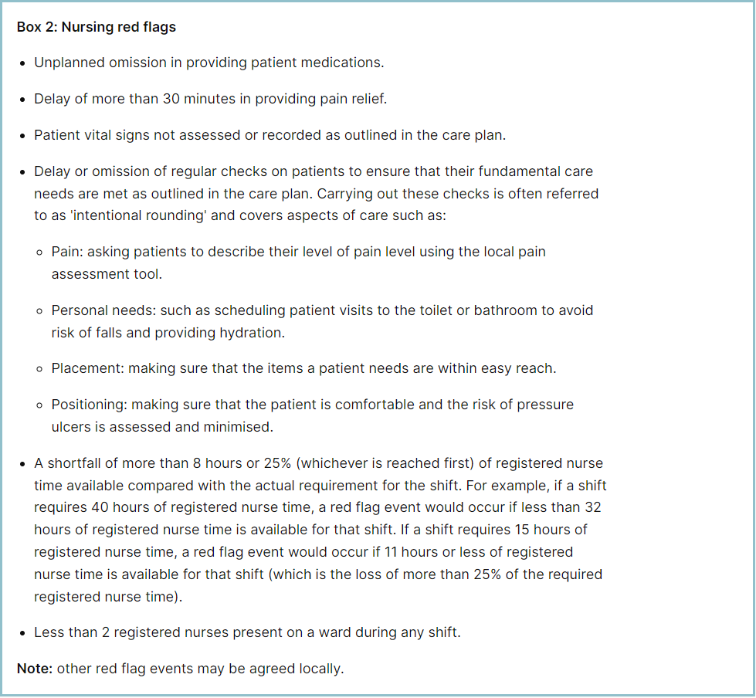

Staffing red flags and trend data

The number of occasions/shifts where the reported fill rate has fallen below 75% across the wards is available in Table 1. This decreased by 27 occasions in December to 99. The majority of these shortfalls were in Maternity, which had 66. Table 2 shows the trend for when registered staffing fell below 75% of standard template.
Table 1. Occasions when registered staffing fell below 75% of standard template

Table 2. Staffing Red Flags Trend Data

Going forward all adult inpatient areas will be capturing staffing shortfalls on SafeCare by raising a Red Flag on the system. Table 3 shows the Red Flags raised through SafeCare in December. The number of Red Flags raised for adult inpatient wards has increased with 86 raised in December against 45 for November following roll out at the end of November
To improve oversight into how many incidents relating to when Enhanced Care could not be provided, the Trust has also added a local Red Flag highlighting when this occurs in SafeCare. This and the addition of Enhanced Care Level 3 Patient task will also enable the Trust to provide data to the Enhanced Care Collaborative and ensure staffing is appropriately deployed. These have now been rolled out across all adult inpatient wards.
There needs to be robust validation of the red flags by managers and matrons to understand which have been mitigated and closed, which is not demonstrated in Table 3 below. This will be a focused aspect of work with the divisions.
Table 3. Red Flags raised via SafeCare December 2024
Row Labels | Delay in providing pain relief | Less than 2 RNs on shift | Missed 'intentional rounding' | Shortfall in RN time | Unable to provide Enhanced Care | Unplanned omission in providing medications | Vital signs not assessed or recorded | Grand Total
AAU |  |  |  | 4 | 6 |  |  | 10
Charnley |  |  |  | 5 | 3 |  |  | 8
Fleming |  | 1 |  | 1 |  |  |  | 2
Henry Moore |  | 2 |  | 2 |  |  |  | 4
Kingsmoor |  |  |  | 1 | 3 |  |  | 4
Locke |  |  |  |  | 1 |  |  | 1
Penn | 4 |  | 3 | 7 | 11 | 1 | 1 | 27
Ray |  |  |  | 4 | 1 |  |  | 5
Saunders |  |  |  |  | 5 |  |  | 5
SDEC |  |  |  | 1 |  |  |  | 1
Tye Green |  |  |  | 3 | 3 |  |  | 6
Winter |  |  | 4 | 9 |  |  |  | 13
Grand Total | 4 | 3 | 7 | 37 | 33 | 1 | 1 | 86
Redeployment

Redeployment of staff continues to be undertaken to support safe staffing as part of the daily staffing huddles. Table 4 details the trend in December with AAU redeploying the highest number of substantive staff with Saunders and Tye Green being the next highest. The highest net receiver of staff was Henry Moore followed by A&E and Nightingale Ward. Table 5 demonstrates the number of substantive staff redeployments per month trend
Table 4. Hours of substantive staff redeployed December 2024

Table 5. Substantive staff redeployment trend
This reports looks at the number of shifts substantive staff working a shift are redployed, it does not include the shifts when agency, bank or multi post holders are redeployed.

Table 6 shows the hours of substantive staff moved as a percentage of total hours worked.
Table 7 shows the hours of all staff including bank and agency, excluding the Enhanced Care Team, Bank Pool and Rapid Response Pool staff.
Table 6. % of substantive staff redeployed as % of total hours worked
Substantive staff hours redeployed | Total hours worked (inc bank and agency) | % of total hours worked / substantive staff redeployed
1694 | 139785 | 1.2%

Table 7. % of staff redeployed as % of total hours worked
All staff hours redeployed (including bank and agency but excluding Enhanced Care Team, Bank Pool and Rapid Response Pool) | Total hours worked (inc bank and agency) | % of total hours worked / staff redeployed (including bank and agency but excluding Enhanced Care Team, Bank Pool and Rapid Response Pool)
3097 | 139785 | 2.21%

The data detailing nurse redeployment indicates that the numbers of staff reassigned are minimal and continues to not be a cause of concern. The redeployment process is efficiently managed with improved governance and oversight.

Appendix 4: Nursing quality indicators

Table 1. Number of falls, unwitnessed falls and falls with harm in December, with the top 3 wards being highlighted

 | Total falls in month | Top 3 wards
Total falls | 88 | Harold 10 | Kingsmoor 8 | Charnley, ED, Saunders & Winter 7 each
Unwitnessed falls | 78 | Harold 9 | Charnley, Kingsmoor & Saunders 7 each
Falls with harm * | 11 | Harvey 3 | ED 2 | All other areas 1
*subject to change following review at Falls Incident Oversight Group

The Trust falls reduction strategy and workplan (2024/2025) remains in place and mandatory falls training has increased to 95%.

Falls Rate per 1000 bed days

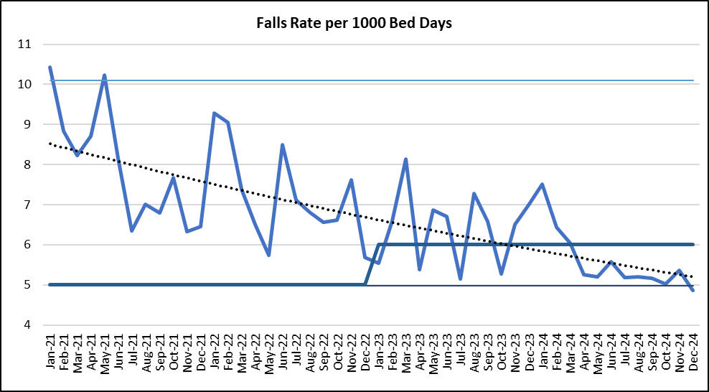

Pressure Ulcers

Table 2. Number of Hospital Acquired Pressure Ulcers (HAPU) Cat 2 and Cat 3 Pressure Ulcers (including unstageable)

In December there was an increase in HAPU, with 29 HAPU’s in month compared to 25 in November.

Total in month | Top 3 wards
29 | Tye Green 7 | ITU 6 | Ray & Charnley  3 each

Total Pressure Ulcer Rate per 1000 bed days and Moderate Harm Pressure Ulcer Rate per 1000 bed days trend.

Complaints, PALS and Compliments Trend Data

Complaints, PALS and Compliments

Table 3. Number of new Complaints, PALS and Compliments in December with top three wards highlighted

 | Total in month | Top 3 wards
New complaints | 31 | A&E 8 | Kingsmoor & Labour Ward 3 each
PALs | 67 | A&E 18 | OPAL 6 | Paeds A&E and Penn 5 each
Compliments | 14 | A&E 5 | Fleming 4 | OPAL & Theatres 2 each

The 3 main PALS themes for December were:
- Delay – 39.1%, Communication – 22.9%, Cancellations – 9.3%

Complaints themes for December were as follows
- Nursing Care – 24.6%, Communication - 15.8% and Delay – 15.1%

