Agenda item:  Presented by:  Prepared by:  Date prepared:  Subject / title: | Giuseppe Labriola – Deputy Chief Nurse  David Dellow – Safe Staffing Lead and Giuseppe Labriola – Deputy Chief Nurse  17.04.2025  Report on Nursing and Midwifery staff levels for February 2025.
Purpose: | Approval |  | Decision |  |  | Information |  | x | Assurance |  | x
Key issues: | - There has been a sustained overall registered fill of > 95%.  - No wards achieved < 75% overall fill rate in month.  - The increase in overall fill rates continue to be driven by enhanced care needs. There is an area of focused work led by the deputy chief nurse to review enhanced care requirements and the governance framework.  - The mid-year establishment review (which informs roster templates) has concluded and is currently under review.
Recommendation: | The committee are asked to note the information within this report.
Trust strategic objectives: |   Patients |   People |  |   Performance |  |  |   Places |  |  |   Pounds
Trust strategic objectives: | x | x |  | x |  |  |  |  |  | x
Previously considered by: | NA
Risk / links with the BAF: | BAF: 2.1 Workforce capacity
Legislation, regulatory, equality, diversity and dignity implications: | NHS England and CQC letter to NHSFT CEOs (31.3.14): Hard Truths Commitment regarding publishing of staffing data.  NHS Improvement letter: 22.4.16  NHS Improvement letter re CHPPD: 29/6/18
Appendices: | Appendix 1: Ward and divisional fill rates by month against adjusted standard planned template.  Appendix 2: Ward and divisional CHPPD data  Appendix 3: Nursing red flags  Appendix 4: Nursing quality indicators

1.0 Introduction
This paper illustrates how PAHT’s nursing and midwifery staffing has been deployed for the month of March 2025. It evidences how planned staffing has been successfully achieved and how this is supported by nursing and midwifery recruitment and deployment.

2.0 Background
The National Quality Board (NQB 2016) recommend that monthly, actual staffing data is compared with expected staffing and reviewed alongside quality of care, patient safety, and patient and staff experience data. The Trust is committed to ensuring that improvements are learned from and celebrated, and areas of emerging concern are identified and addressed promptly. This paper will identify safe staffing and actions taken in March 2025. The following sections identify the processes in place to demonstrate that the Trust proactively manages nursing and midwifery staffing to support patient safety.
3.0 Inpatient wards fill rate
The Trust’s safer staffing submission has been submitted to NHS Digital for March 2025 within the data submission deadline. Table 1 shows the summary of the overall fill rate for this month. Table 2 shows a summary of overall fill rate percentages for a rolling 12-month period.
Appendix 1 illustrates a ward-by-ward breakdown for this period.
3.1 Wards with < 75% average fill rate
No wards that had an overall fill rate of < 75%:
3.2 Wards with > 100% average fill rate
Henry Moore Ward has an increased fill rate due to fluctuating capacity and opening of additional surgical beds and a Level 1 area for post-operative patients, the Level 1 bay is staffed by ITU and the staffing is reflected in their numbers. Therefore, the additional staff are reflective of the required workforce to meet the activity demands.
The impact of staffing requirements for patients requiring enhanced care is shown in the number of wards which continue to have greater than 100% fill rate. The fill rate is based against the standard ward template
Greater than 100% fill rate for Registered Nurse (RN) and Healthcare support worker (HCSW) shifts continues to be mainly attributable to enhanced care requirements, the deputy chief nurse is facilitating a working group reviewing enhanced care requirements.
The Trust continues to utilise NHS Professionals and agency (for registered mental health nurses) to mitigate vacant shifts. Additional control measures continue to be in place regarding the creation of additional duties. Furthermore, our senior nurses and midwives are also supporting individual areas when required. SafeCare data continues to be collected three times a day to enhance staffing governance across the organisation.
Further detail can be found in Appendix 1

Table 1. Overall fill rate
Average day fill rate - registered nurses/midwives | Average day fill rate - care staff | Average night fill rate - registered nurses/midwives | Average night fill rate - care staff | % Registered overall fill rate | % HCSW overall fill rate | % Overall fill rate
95.8% | 95.9% | 102.0% | 130.8% | 98.5% | 111.5% | 102.8%

Table 2. Inpatient fill rate including Maternity Wards Trend

4.0 Care Hours Per Patient Day (CHPPD)

CHPPD allows comparison of a ward’s CHPPD figure with that of other wards in the hospital, or with similar wards in other hospitals. It can be used to look at variation between similar wards to ensure the right staff are being used in the right way and in the right numbers.
The hours worked during day and night shifts by registered nurses and midwives and healthcare assistants are added together. This figure is then divided by the number of patients at midnight, this then gives the total CHPPD
By itself, the CHPPD does not reflect the total amount of care provided on a ward nor does it directly show whether care is safe, effective or responsive. It should therefore be considered alongside measures of quality and safety.
Table 3. Overall Care Hours Per Patient Day (CHPPD) March 2025

Registered CHPPD | Unregistered CHPPD | Total CHPPD
5.1 | 2.8 | 7.9
The Model Hospital data for January 2025 shows the Trust with a CHPPD of 7.7 against the national median of 8.5. Table 4 also shows the Trusts total CHPPD against our peers (East and North Hertfordshire NHS Trust and West Hertfordshire Teaching Hospitals NHS Trust)
Appendix 2 shows the individual ward and divisional CHPPD for March 2025
Table 4. CHPPD Trend

5.0 Quality Indicators

5.1 Nursing Red Flags
Nursing red flags prompt an immediate response by the registered nurse in charge of the ward. The response may include allocating additional nursing staff to the ward or other appropriate responses. Appendix 3 details the NICE (2014) definition of Nursing Red Flags, the number of occasions when registered staffing fell below 75% of the standard template and trend and the number of Red Flags raised in SafeCare. Currently, this information cannot be monitored for all nursing red flags on the DATIX system and a system has been implemented to capture these in SafeCare.
5.2 Quality indicators (Falls, pressure ulcers and complaints, PALS and compliments)

Nursing quality indicators have been reviewed and there is no correlation between these, fill rates or red flags which are a cause of concern. A review of quality indicators can be found in Appendix 4.

6.0 Conclusion
The Trust continues to achieve a sustained overall registered fill of > 95%. The increase in overall fill rates is due to enhanced care needs. There is an area of focused work led by the deputy chief nurse to review enhanced care requirements and the governance framework.
7.0 Recommendation
The committee are asked to note the information in this report to provide assurance on the daily mitigation of nursing and midwifery staffing.

Appendix 1: Ward level data and narrative: fill rates March 2025 (Adjusted Standard Planned Ward Demand)
>100% | 95 – 100% | 75-95% | <75%

 | Day |  | Night
Ward name | Average fill rate - registered nurses/midwives (%) | Average fill rate - care staff (%) | Average fill rate - registered nurses/midwives (%) | Average fill rate - care staff (%) | % Registered overall fill rate | % HCSW overall fill rate | % Overall fill rate
Harvey | 83.3% | 121.5% | 101.2% | 157.1% | 90.6% | 138.5% | 107.9%
Henry Moore | 132.8% | 130.5% | 180.4% | 148.1% | 151.8% | 138.9% | 146.2%
ITU & HDU | 91.4% | 29.0% | 95.6% | 97.1% | 93.5% | 63.0% | 90.7%
John Snow | 104.3% | 41.9% | 100.0% | 64.5% | 102.2% | 49.0% | 79.3%
Penn | 100.3% | 108.0% | 104.0% | 177.9% | 101.8% | 134.5% | 113.5%
Saunders | 93.2% | 107.0% | 123.1% | 169.8% | 104.4% | 130.8% | 114.4%
Surgery Total | 97.4% | 97.3% | 109.0% | 146.5% | 102.5% | 117.7% | 107.1%
Fleming | 88.4% | 97.4% | 99.9% | 127.3% | 93.3% | 111.7% | 98.9%
Harold | 92.1% | 91.9% | 100.5% | 118.0% | 95.8% | 104.4% | 98.5%
Kingsmoor | 89.8% | 124.9% | 107.6% | 148.7% | 96.6% | 136.3% | 111.4%
Lister | 96.2% | 97.2% | 102.0% | 128.7% | 98.6% | 112.3% | 104.1%
Locke | 94.6% | 112.1% | 99.0% | 156.1% | 96.5% | 133.1% | 111.1%
Nightingale | 102.3% | 86.7% | 101.5% | 206.2% | 101.9% | 124.2% | 111.5%
Opal | 101.2% | 97.5% | 84.9% | 112.9% | 93.4% | 104.9% | 98.0%
Ray | 103.3% | 95.7% | 114.3% | 174.5% | 108.0% | 125.6% | 114.3%
Tye Green | 97.3% | 86.8% | 101.0% | 150.5% | 98.9% | 112.7% | 104.3%
Winter | 97.7% | 95.6% | 100.8% | 121.3% | 99.0% | 107.9% | 102.5%
Medicine Total | 95.4% | 98.7% | 101.5% | 140.2% | 98.0% | 117.4% | 105.2%
AAU | 97.2% | 112.5% | 106.4% | 138.0% | 101.3% | 124.7% | 106.2%
Charnley | 91.9% | 143.8% | 99.9% | 164.3% | 95.7% | 153.6% | 112.3%
UEC Total | 95.1% | 128.2% | 103.7% | 151.2% | 99.1% | 139.2% | 108.8%
Birthing | 84.9% | 86.8% | 74.7% | 77.4% | 80.0% | 82.3% | 80.8%
Chamberlen | 95.3% | 61.4% | 87.9% | 57.8% | 91.8% | 59.6% | 83.8%
Dolphin | 102.5% | 61.6% | 120.8% | 103.9% | 110.6% | 75.7% | 101.9%
Labour | 91.1% | 83.9% | 87.6% | 95.0% | 89.4% | 89.2% | 89.4%
Neo-Natal Unit | 93.0% | 88.1% | 97.1% | 80.6% | 95.1% | 84.4% | 93.3%
Samson | 100.3% | 74.7% | 91.3% | 81.4% | 96.0% | 77.9% | 85.6%
CHAWS Total | 94.8% | 75.2% | 94.8% | 83.6% | 94.8% | 79.0% | 90.1%
Total | 95.8% | 95.9% | 102.0% | 130.8% | 98.5% | 111.5% | 102.8%

John Snow Ward - continues to have fluctuating capacity and has not consistently been sending 1 of the 2-day HCSW shifts to NHS Professionals (NHSP). The HCSW night shift is being filled, though depending on overnight patient numbers and acuity these staff may be redeployed to other areas.
Critical Care - it has been identified in the divisional roster reviews that critical care are not consistently sending all HCSW shifts out to NHSP, the division is currently reviewing the critical care establishment. A recruitment campaign for support workers took place in February, for surgery and critical care where 2.0 WTE were offered critical care.
Nightingale Ward - fillrate is currently affected due to the wards standard template and the use of optional shifts, these hours are counted but are not part of the standard template leading to a high fillrate, when used. Discussions have been held with the ADoN and the optional night HCA shift has been removed and converted to a standard shift from the 12th May Roster aligning the template with the SNCT results. This should start to have an impact on the fillrate for ward in the May paper.
Maternity - the service continues to robustly review staffing through twice weekly staffing reviews and the use of Birthrate Plus. Safety is maintained by daily staffing huddles and staff deployment according to acuity, support continues to be provided by specialist midwives and matrons being redeployed as required.
The Trust continues as part of an Enhanced Care Collaborative working group supported by NHS England that is reviewing the provision of Enhanced Care including the workforce and training requirements to sustainably manage this demand.
The interim establishment review (which underpins the rota templates) commenced in March 2025 and finished 1st April 2025 This is for adult and paediatric inpatient wards and assessment units along with main and paediatric emergency departments.
Emergency Departments - National reporting is currently for inpatient areas and therefore does not include areas including the emergency department (ED). To ensure the Board is sighted to staffing in these areas, the data for ED and Paediatric ED is included below (Appendix 1a and 1b) using the same methodology as the full UNIFY report.

Appendix 1a: ED data and narrative: fill rates March 2025 (Standard Planned Demand)

Average day fill rate - registered nurses/midwives | Average day fill rate - care staff | Average night fill rate - registered nurses/midwives | Average night fill rate - care staff | % Registered overall fill rate | % HCSW overall fill rate | % Overall fill rate
99.5% | 77.5% | 116.3% | 95.1% | 107.0% | 85.3% | 100.1%

Appendix 1b: Paediatric ED data and narrative: fill rates March 2025 (Standard Planned Demand)

Average day fill rate - registered nurses/midwives | Average day fill rate - care staff | Average night fill rate - registered nurses/midwives | Average night fill rate - care staff | % Registered overall fill rate | % HCSW overall fill rate | % Overall fill rate
133.7% | 69.2% | 145.1% | 96.8% | 138.8% | 83.0% | 121.6%

Appendix 2: Ward level data: CHPPD March 2025

Care Hours Per Patient Day (CHPPD)
Ward | Registered Nurses/Midwives | Non-registered Nurses/Midwives | Overall
Trust Total | 5.1 | 2.8 | 7.9
Harvey Ward | 3.8 | 3.3 | 7.2
Henry Moore Ward | 4.1 | 2.9 | 7.0
ITU & HDU | 18.0 | 1.2 | 19.2
John Snow Ward | 5.2 | 1.9 | 7.1
Penn Ward | 3.9 | 2.9 | 6.8
Saunders Unit | 3.7 | 2.8 | 6.6
Surgery Total | 5.4 | 2.7 | 8.1
Fleming Ward | 3.9 | 2.0 | 5.9
Harold Ward | 4.5 | 2.3 | 6.8
Kingsmoor General | 3.6 | 3.0 | 6.6
Lister Ward | 4.0 | 3.0 | 7.0
Locke Ward | 3.6 | 3.3 | 6.9
Nightingale Ward | 2.9 | 2.7 | 5.6
Opal Unit | 5.8 | 4.4 | 10.2
Ray Ward | 4.7 | 3.0 | 7.7
Tye Green Ward | 4.6 | 3.3 | 7.9
Winter Ward | 3.7 | 2.7 | 6.4
Medicine Total | 4.1 | 2.9 | 7.0
AAU | 6.9 | 2.3 | 9.2
Charnley Ward | 4.5 | 2.9 | 7.4
UEC Total | 5.7 | 2.6 | 8.3
Birthing Unit | 16.3 | 8.4 | 24.7
Chamberlen Ward | 5.8 | 1.3 | 7.1
Dolphin Ward | 9.3 | 2.1 | 11.4
Labour Ward | 24.0 | 6.8 | 30.8
Neo-Natal Unit | 9.2 | 1.6 | 10.8
Samson Ward | 2.5 | 2.7 | 5.3
CHAWS Total | 7.7 | 2.8 | 10.5

Appendix 3. Nursing Red Flags (NICE 2014) and trend data

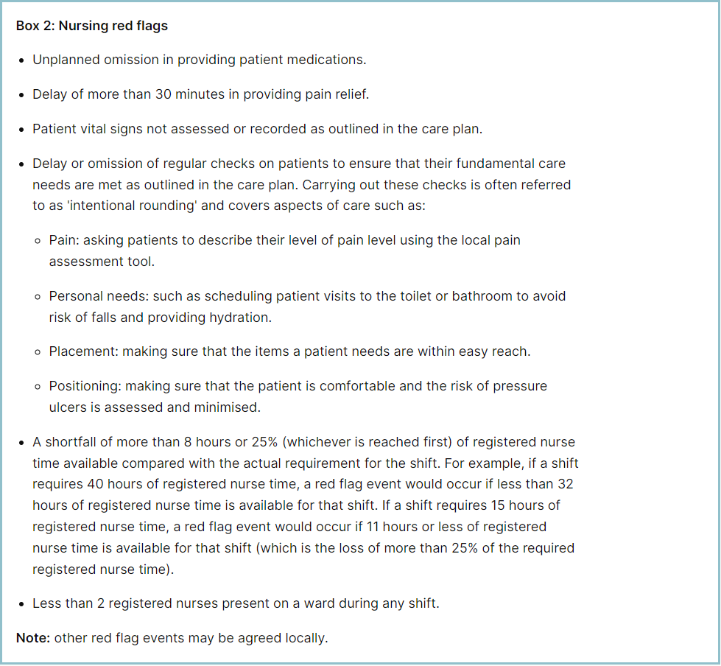

Staffing red flags and trend data

The number of occasions/shifts where the reported fill rate has fallen below 75% across the wards is available in Table 1. This increased by 13 occasions in March 2025 to 84. The majority of these shortfalls continue to be in Maternity, which had 57. Table 2 shows the trend for when registered staffing fell below 75% of standard template.
Table 1. Occasions when registered staffing fell below 75% of standard template February 2025

Table 2. Occasions when registered staffing fell below 75% of standard template
Trend Data April 2024 – March 2025

All adult inpatient areas should be capturing staffing shortfalls on SafeCare by raising a Red Flag on the system, refresher training by the Safe Staffing and Enhanced Care Leads has been undertaken. Table 3a shows the Red Flags raised through SafeCare in March 2025. Table 3b shows the number of Red Flags raised for adult inpatient wards has increased with 77 raised in March against 51 for February.
To improve oversight into how many incidents relating to when Enhanced Care could not be provided, the Trust has also added a local Red Flag highlighting when this occurs in SafeCare. This and the addition of Enhanced Care Level 3 Patient task will also enable the Trust to provide data to the Enhanced Care Collaborative and ensure staffing is appropriately deployed. These have now been rolled out across all adult inpatient wards.
There needs to be robust validation of the red flags by managers and matrons to understand which have been mitigated and closed, which is not currently demonstrated in Table 3a below. This will be a focused aspect of work with the divisions.
Table 3a. Red Flags raised via SafeCare March 2025

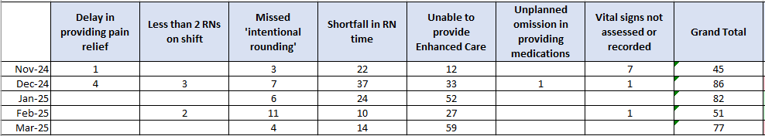
Table 3b. Red Flags raised via SafeCare Trend

Redeployment

Redeployment of staff continues to be undertaken to support safe staffing as part of the daily staffing huddles. Table 4 details the trend in March 2025 with Tye Green redeploying the highest number of substantive staff with AAU and Lister Ward being the next highest. Although Tye Green deployed the highest amount of staff, Safe Care was used to inform this decision making which include a review of patient activity and acuity. The highest net receiver of staff was Henry Moore followed by Locke and Fleming Ward. Table 5 demonstrates the number of substantive staff redeployments per month trend
Table 4. Hours of substantive staff redeployed March 2025

Table 5. Substantive staff redeployment trend
This reports looks at the number of shifts substantive staff working a shift are redployed, it does not include the shifts when agency, bank or multi post holders are redeployed.

Table 6 shows the hours of substantive staff moved as a percentage of total hours worked.
Table 7 shows the hours of all staff including bank and agency, excluding the Enhanced Care Team, Bank Pool and Rapid Response Pool staff.
Table 6. % of substantive staff redeployed as % of total hours worked
Substantive staff hours redeployed | Total hours worked (inc bank and agency) | % of total hours worked / substantive staff redeployed
852 | 140605 | 0.61%

Table 7. % of staff redeployed as % of total hours worked
All staff hours redeployed (including bank and agency but excluding Enhanced Care Team, Bank Pool and Rapid Response Pool) | Total hours worked (inc bank and agency) | % of total hours worked / staff redeployed (including bank and agency but excluding Enhanced Care Team, Bank Pool and Rapid Response Pool)
1987 | 140605 | 1.41%

The data detailing nurse redeployment indicates that the numbers of staff reassigned are minimal and continues to not be a cause of concern. The redeployment process is efficiently managed with improved governance and oversight.

Appendix 4: Nursing quality indicators

Table 1. Number of falls, unwitnessed falls and falls with harm in March 2025, with the top 3 wards being highlighted

 | Total falls in month | Top 3 wards
Total falls | 97 | Locke 12 | Kingsmoor 11 | Tye Green 11
Unwitnessed falls | 89 | Locke 12 | Tye Green 11 | Kingsmoor 10
Falls with harm * | 18 | Tye Green 3 | Nightingale 3 | Ray 3
*subject to change following review at Falls Incident Oversight Group

The Trust falls reduction strategy and workplan (2024/2025) remains in place and mandatory falls training has increased to 97%.

Falls Rate per 1000 bed days

Pressure Ulcers

Table 2. Number of Hospital Acquired Pressure Ulcers (HAPU) Cat 2 and Cat 3 Pressure Ulcers (including unstageable)

In March 2025 there was an increase in HAPU, with 28 HAPU’s in month compared to 27 in February.

Total in month | Top 3 wards
28 | Tye Green - 6 | Winter, Saunders and ITU & HDU - 4

Total Pressure Ulcer Rate per 1000 bed days and Moderate Harm Pressure Ulcer Rate per 1000 bed days trend.

Complaints, PALS and Compliments Trend Data Septemebr 2024 – February 2025

Complaints, PALS and Compliments

Table 3. Number of new Complaints, PALS and Compliments in March 2025 with top three wards highlighted

 | Total in month | Top 3 wards
New complaints | 19 | A&E 4 | Penn 3 | Labour and Ray 2
PALs | 64 | A&E 21 | Kingsmoor 6 | Henry Moore and Penn 4
Compliments | 3 | A&E 2 | Harvey 1

Not all compliments received in March have been logged in this month’s data.

The 3 main PALS themes for February were:
- Delay – 37.6%, Communication – 27.75%, Cancellations – 11.33%

Complaints themes for February were as follows
Medical care – 23.29%, Appointments 19.18% and Delays – 13.7%

