Agenda item:  Presented by:  Prepared by:  Date prepared:  Subject / title: | Jo Ward – Deputy Chief Nurse  David Dellow – Safe Staffing Lead and Jo Ward – Deputy Chief Nurse  19.11 2024  Report on Nursing and Midwifery staff levels for October 2024.
Purpose: | Approval |  | Decision |  |  | Information |  | x | Assurance |  | x
Key issues: | No ward reported average fill rates below 75% for RN’s against the standard planned template during the reporting period. Increase in overall fill rates is multifaced with a combination of enhanced care needs and supernumerary time driving this. The full year establishment review currently underway will provide oversight and recommendations for practice  practice.
Recommendation: | The committee are asked to note the information within this report.
Trust strategic objectives: |   Patients |   People |  |   Performance |  |  |   Places |  |  |   Pounds
Trust strategic objectives: | x | x |  | x |  |  |  |  |  | x
Previously considered by: | NA
Risk / links with the BAF: | BAF: 2.1 Workforce capacity  All divisions have both recruitment and retention on their risk registers
Legislation, regulatory, equality, diversity and dignity implications: | NHS England and CQC letter to NHSFT CEOs (31.3.14): Hard Truths Commitment regarding publishing of staffing data.  NHS Improvement letter: 22.4.16  NHS Improvement letter re CHPPD: 29/6/18
Appendices: | Appendix 1: Ward and divisional fill rates by month against adjusted standard planned template. RAG rated.  Appendix 2: Ward and divisional CHPPD data  Appendix 3: Nursing Red Flags (NICE 2014)  Appendix 4: Occasions when registered staffing fell below 75% trend  Appendix 5: Substantive staff redeployment trend  Appendix 6: Falls SPC charts  Appendix 7: Pressure Ulcers SPC charts  Appendix 8: Complaints, PALS and Compliments Trend

1.0 Introduction
This paper illustrates how PAHT’s nursing and midwifery staffing has been deployed for the month of October 2024. It evidences how planned staffing has been successfully achieved and how this is supported by nursing and midwifery recruitment and deployment.

2.0 Background
The National Quality Board (NQB 2016) recommend that monthly, actual staffing data is compared with expected staffing and reviewed alongside quality of care, patient safety, and patient and staff experience data. The trust is committed to ensuring that improvements are learned from and celebrated, and areas of emerging concern are identified and addressed promptly. This paper will identify safe staffing and actions taken in October 2024. The following sections identify the processes in place to demonstrate that the Trust proactively manages nursing and midwifery staffing to support patient safety.
3.0 Inpatient wards fill rate

The Trust’s safer staffing submission has been submitted to NHS Digital for October 2024 within the data submission deadline. Table 1 shows the summary of the overall fill rate for this month. Appendix 1 illustrates a ward-by-ward breakdown for this period. Table 2 shows a summary of overall fill rate percentages for a rolling 12-month period.
John Snow Ward continues to have fluctuating capacity and has not consistently been sending 1 of the 2 day HCA shifts to NHSP. The HCA night shift is being filled, though depending on overnight patient numbers and acuity these staff may be redeployed to other areas. These factors continue to impact on the number of HCA shifts being redeployed from the ward during October, and continue to impact on the HCA fill rate for day and night. As part of the full year establishment review this will be reviewed and a recommendation made based on predicted activity for in-patient elective orthopaedic surgery.
Henry Moore Ward has an increased fill rate due to opening of additional elective surgical beds and a Level 1 area for post-operative patients, the Level 1 bay is staffed by ITU and the staffing is reflected in their numbers. If the Level one bay is not required then it is opened up to elective patients and extra staff booked if required. This is being reviewed as part of the full year establishment review
Maternity continue to robustly review staffing through twice weekly staffing reviews and use of Birthrate Plus. Safety is maintained by daily staffing huddles and staff deployment according to acuity, while support is provided by specialist practitioners and Matrons being redeployed as required. Maternity has on going recruitment of HCSW to improve numbers throughout all maternity areas.
The impact of staffing requirements for patients requiring enhanced care is shown in the number of wards which continue to have greater than 100% fillrate, this is especially demonstrated in wards such as Penn, Saunders and Ray night fillrate for HCAs. The fillrate is based against the standard ward template
The Trust is part of an Enhanced Care Collaborative working group supported by NHSE that is reviewing the provision of Enhanced Care including the workforce and training requirements to sustainably manage this demand. The full year establishment review completed in October 2024 with consideration of the Enhanced Care Collaborative findings will review the continued demand above established templates for enhanced care need and will makes a recommendation for how this demand is planned for going forward.
Greater than 100% fill rate for RN shifts is attributable to RMN 1:1 requirements or supporting the induction of newly qualified/registered RNs.
We continue to utilise NHS Professionals (NHSP) and agency to mitigate vacant shifts, though continue to reduce our temporary staffing pools. New control measures have been put in place regarding the creation of additional duties. In addition, our senior nurses and midwives are also supporting individual areas if required. SafeCare data continues to be collected three times a day to improve staffing governance across the organisation.
Table 1. Overall fill rate
Average day fill rate - registered nurses/midwives | Average day fill rate - care staff | Average night fill rate - registered nurses/midwives | Average night fill rate - care staff | % Registered overall fill rate | % HCSW overall fill rate | % Overall fill rate
93.9% | 1074.8% | 101% | 131.2% | 97.1% | 118.2% | 103.9%

Table 2. Inpatient fill rate including Maternity Wards Trend

4.0 Care Hours Per Patient Day (CHPPD)
CHPPD allows comparison of a ward’s CHPPD figure with that of other wards in the hospital, or with similar wards in other hospitals. It can be used to look at variation between similar wards to ensure the right staff are being used in the right way and in the right numbers.
The hours worked during day and night shifts by registered nurses and midwives and healthcare assistants are added together. This figure is then divided by the number of patients at midnight, this then gives the total CHPPD. The number of registered and unregistered hours can be divided by the number of patients to understand the registered and unregistered CHPPD.
By itself the CHPPD does not reflect the total amount of care provided on a ward nor does it directly show whether care is safe, effective or responsive. It should therefore be considered alongside measures of quality and safety.
Table 3. Overall Care Hours Per Patient Day (CHPPD) September 2024
Registered CHPPD | Unregistered CHPPD | Total CHPPD
4.8 | 2.8 | 7.6

The Model Hospital data for August 2024 shows the Trust with a CHPPD of 7.8 against the national median of 8.7. Table 4 also now shows the Trusts total CHPPD against our peers (East and North Hertfordshire NHS Trust and West Hertfordshire Teaching Hospitals NHS Trust)
Appendix 2 shows the individual ward and divisional CHPPD for October 2024

Table 4. CHPPD Trend

5.0 Quality Indicators

5.1 Nursing Red Flags
Nursing red flags prompt an immediate response by the registered nurse in charge of the ward. The response may include allocating additional nursing staff to the ward or other appropriate responses. Appendix 3 details the NICE (2014) definition of Nursing Red Flags. Currently this information cannot be monitored for all nursing red flags on the DATIX incident reporting system. Following a meeting on the 4th September chaired by the Deputy Chief Nurse (Interim) to discuss capturing Red Flags going forward it was decided that, due to the current configuration of SafeCare and the implementation of Alex Health we will delay introducing a new process to support additional oversight of Red Flags until Alex Health has been implemented.
In the interim a trial of using SafeCare to capture Red Flags continues on Winter Ward to support an informed decision about how the process will work following the launch of Alex Health. Initial results are below
Row Labels | Missed  'intentional rounding' | Shortfall in RN time | Vital signs not assessed or recorded | Grand Total
Winter Ward | 7 | 4 | 5 | 16
Grand Total | 7 | 4 | 5 | 16

Row Labels | Open | Resolved | Grand Total
Missed 'intentional rounding' | 3 | 4 | 7
Shortfall in RN time | 2 | 2 | 4
Vital signs not assessed or recorded |  | 5 | 5
Grand Total | 5 | 11 | 16

This report already captures staffing of less than 75% and less than 2 RNs on a shift.
The Trust has a robust Red Flag three times daily staffing review process where issues are raised, discussed and escalated.
Moving forward all areas will be capturing staffing shortfalls on SafeCare by raising a Red Flag on the system. To improve oversight into how many incidents relating to when Enhanced Care could not be provided, the Trust has added a local Red Flag highlighting when this occurs in SafeCare. This is being trialled in AAU and Charnley along with the roll out of red flags. This will also enable the Trust to provide data to the Enhanced Care Collaborative.
The training and roll out plan for both Red Flags and Enhanced Care Level 3 patients is all wards will be live for both by 1st January 2025.
A shortfall of more than 8 hours or 25% (whichever is reached first) of registered nurse time available, compared with the actual requirement for the shift is a nursing red flag.
The number of occasions/shifts where the reported fill rate has fallen below 75% across the wards is available in Table 5. This decreased by 17 occasions in October to 101. The majority of these were in Maternity, which had a reduction of 24 in October to 64.
Appendix 4 details the staffing red flags trend.

Table 5. Occasions when registered staffing fell below 75% of standard template

5.2 Falls

Table 6. Number of falls, unwitnessed falls and falls with harm in October, with the top 3 wards being highlighted
 | Total falls in month | Top 3 wards
Total falls | 86 | Fleming 9 | Charnley 8 |  | ED, Kingsmoor and Tye Green 7 each
Unwitnessed falls | 60 | Fleming 8 | Charnley 7 |  | Kingsmoor and Saunders 5 each
Falls with harm * | 12 | Fleming and Penn 2 each |  | AAU, ED, Endoscopy, Harvey, HMU, Lister, OPAL and Tye Green 1 each
*subject to change following review at Falls Incident Oversight Group
The Trust falls reduction strategy and workplan (2024/2025) remains in place and mandatory falls training has increased to 95%.

5.3 Pressure Ulcers

Table 7. Number of Hospital Acquired Pressure Ulcers (HAPU) Cat 2 and Cat 3 Pressure Ulcers (including unstageable)

In October there was a significant increase in HAPU, with 20 HAPU’s in October compared to 12 last month.

This month, the highest number of HAPUs developed on Harold, OPAL and Winter with 3 each.

Tissue Viability will continue the focus on PURPOSE T and related care implementations on AlexHealth across all clinical areas help embed the required care delivery for pressure ulcer prevention.

5.4 Complaints, PALS and Compliments

Table 8. Number of new Complaints, PALS and Compliments in October with top three wards highlighted
 | Total in month | Top 3 wards
New complaints | 18 | A&E 4 | Lister 3 | Harvey, ITU & Tye Green 2 each
PALs | 107 | A&E 28 | Paeds ED 8 | Kingsmoor & Lister 6 each
Compliments | 18 | Fleming 6 | A&E 4

The 3 main PALS themes for October were:
- Delay – 33.38%, Communication – 24.8%, Cancellations – 11.36%

Complaints themes for October were as follows
- Medical Care – 12.86% Nursing Care – 18.57% and Communication 24.29%

Appendix 8 shows the trend for complaints, PALs and compliments.

6.0 Redeployment
Redeployment of staff continues to be undertaken to support safe staffing as part of the daily staffing huddles. Table 10 details the trend in October with ITU redeploying the highest number of substantive staff with AAU being the next highest. The highest net receiver of staff was A&E followed by Henry Moore and Saunders Ward. Appendix 5 demonstrates the number of substantive staff redeployments per month trend
Table 10. Hours of substantive staff redeployed October 2024

Table 11 shows the hours of substantive staff moved as a percentage of total hours worked.
Table 12 shows the hours of all staff including bank and agency, excluding the Enhanced Care Team, Bank Pool and Rapid Response Pool staff.
Table 11. % of substantive staff redeployed as % of total hours worked
Substantive staff hours redeployed | Total hours worked (inc bank and agency) | % of total hours worked / substantive staff redeployed
911 | 140956 | 0.65%

Table 12. % of staff redeployed as % of total hours worked
All staff hours redeployed (including bank and agency but excluding Enhanced Care Team, Bank Pool and Rapid Response Pool) | Total hours worked (inc bank and agency) | % of total hours worked / staff redeployed (including bank and agency but excluding Enhanced Care Team, Bank Pool and Rapid Response Pool)
2005 | 140956 | 1.42%

The data detailing nurse redeployment indicates that the numbers of staff reassigned are minimal and continues to not be a cause of concern. The redeployment process is efficiently managed with improved governance and oversight.
7.0 Conclusion
This paper will evolve in the future to include the impact of staffing including additional nursing and midwifery sensitive indicators such as compliance with nationally mandated staffing such as CNST provision in midwifery. The paper will also demonstrate initiatives underway to review staffing establishments and activities to ensure nursing and midwifery workforce is deployed in the most cost-efficient way.
This is due to be reviewed following the full year establishment review undertaken between 2nd September and 1st October 2024 and maternity workforce review using Birth Rate plus which commenced in October 2024 and due for completion in early 2025.

8.0 Recommendation
The committee are asked to note the information in this report to provide assurance on the daily mitigation of nursing and midwifery staffing.

Appendix 1: Ward level data: fill rates October 2024. (Adjusted Standard Planned Ward Demand)
>100% | 95 – 100% | 75-95% | <75%

 | Day |  | Night
Ward name | Average fill rate - registered nurses/midwives (%) | Average fill rate - care staff (%) | Average fill rate - registered nurses/midwives (%) | Average fill rate - care staff (%) | % Registered overall fill rate | % HCSW overall fill rate | % Overall fill rate
Harvey | 84.4% | 132.4% | 100.0% | 131.3% | 90.8% | 131.9% | 105.7%
Henry Moore | 107.4% | 124.8% | 139.2% | 140.5% | 120.1% | 132.3% | 125.4%
ITU & HDU | 100.6% | 53.3% | 104.8% | 103.2% | 102.7% | 78.3% | 100.5%
John Snow | 106.3% | 44.0% | 100.0% | 61.6% | 103.3% | 49.5% | 80.0%
Penn | 93.7% | 122.3% | 100.4% | 200.0% | 96.5% | 151.8% | 116.3%
Saunders | 92.4% | 120.9% | 123.2% | 176.9% | 103.9% | 142.2% | 118.3%
Surgery Total | 96.8% | 106.7% | 108.6% | 146.0% | 102.0% | 123.1% | 108.3%
Fleming | 83.1% | 97.1% | 99.3% | 108.0% | 90.0% | 102.3% | 93.7%
Harold | 94.6% | 91.9% | 101.7% | 102.2% | 97.7% | 96.8% | 97.4%
Kingsmoor | 89.2% | 111.2% | 102.0% | 143.7% | 94.0% | 126.8% | 106.3%
Lister | 96.6% | 124.6% | 102.4% | 126.1% | 99.1% | 125.3% | 109.5%
Locke | 96.5% | 127.6% | 102.6% | 151.3% | 99.1% | 139.0% | 115.0%
Nightingale | 114.9% | 84.3% | 101.6% | 187.4% | 108.5% | 116.7% | 112.0%
Opal | 101.9% | 115.8% | 97.1% | 114.6% | 99.6% | 115.2% | 105.8%
Ray | 98.5% | 118.0% | 113.9% | 170.5% | 105.1% | 137.9% | 116.8%
Tye Green | 93.7% | 99.4% | 98.2% | 142.2% | 95.7% | 116.8% | 103.9%
Winter | 93.7% | 128.6% | 99.9% | 130.8% | 96.3% | 129.6% | 109.6%
Medicine Total | 94.6% | 110.6% | 101.9% | 134.5% | 97.7% | 121.4% | 106.6%
AAU | 89.9% | 152.1% | 105.6% | 152.6% | 96.9% | 152.3% | 108.5%
Charnley | 106.3% | 118.8% | 114.2% | 125.9% | 110.1% | 122.2% | 113.5%
UEC Total | 96.2% | 135.4% | 109.2% | 139.2% | 102.1% | 137.2% | 110.6%
Birthing | 91.8% | 81.6% | 76.8% | 93.2% | 84.6% | 87.1% | 85.5%
Chamberlen | 94.0% | 47.4% | 94.4% | 90.3% | 94.2% | 68.0% | 87.7%
Dolphin | 79.1% | 62.7% | 89.7% | 95.2% | 83.8% | 73.5% | 81.3%
Labour | 93.0% | 90.1% | 89.8% | 97.9% | 91.5% | 93.8% | 92.0%
Neo-Natal Unit | 83.0% | 125.8% | 89.0% | 90.6% | 86.0% | 108.2% | 89.7%
Samson | 89.7% | 112.4% | 80.0% | 119.0% | 85.1% | 115.5% | 100.3%
CHAWS Total | 88.0% | 89.8% | 87.9% | 102.4% | 88.0% | 95.6% | 90.1%
Total | 93.9% | 107.8% | 101.0% | 131.2% | 97.1% | 118.2% | 103.9%

Appendix 2: Ward level data: CHPPD October 2024.

Care Hours Per Patient Day (CHPPD)
Ward | Registered Nurses/Midwives | Non-registered Nurses/Midwives | Overall
Trust Total | 4.8 | 2.8 | 7.6
Harvey Ward | 3.7 | 3.1 | 6.8
Henry Moore Ward | 3.7 | 3.1 | 6.8
ITU & HDU | 20.1 | 1.5 | 21.6
John Snow Ward | 5.3 | 1.9 | 7.2
Penn Ward | 3.7 | 3.3 | 7.0
Saunders Unit | 3.8 | 3.1 | 6.9
Surgery Total | 5.6 | 2.9 | 8.5
Fleming Ward | 3.7 | 1.8 | 5.5
Harold Ward | 4.7 | 2.1 | 6.8
Kingsmoor General | 3.5 | 2.8 | 6.3
Lister Ward | 3.7 | 3.1 | 6.9
Locke Ward | 3.7 | 3.5 | 7.2
Nightingale Ward | 3.1 | 2.5 | 5.6
Opal Unit | 4.1 | 3.2 | 7.3
Ray Ward | 3.9 | 2.9 | 6.8
Tye Green Ward | 4.1 | 3.2 | 7.3
Winter Ward | 3.6 | 3.2 | 6.8
Medicine Total | 3.8 | 2.8 | 6.7
AAU | 6.4 | 2.7 | 9.0
Charnley Ward | 4.9 | 2.2 | 7.1
UEC Total | 5.6 | 2.4 | 8.1
Birthing Unit | 8.3 | 4.3 | 12.5
Chamberlen Ward | 5.0 | 1.2 | 6.2
Dolphin Ward | 6.5 | 1.9 | 8.4
Labour Ward | 11.4 | 3.3 | 14.8
Neo-Natal Unit | 7.7 | 1.9 | 9.6
Samson Ward | 3.2 | 4.4 | 7.6
CHAWS Total | 6.6 | 2.8 | 9.4

Appendix 3. Nursing Red Flags (NICE 2014)

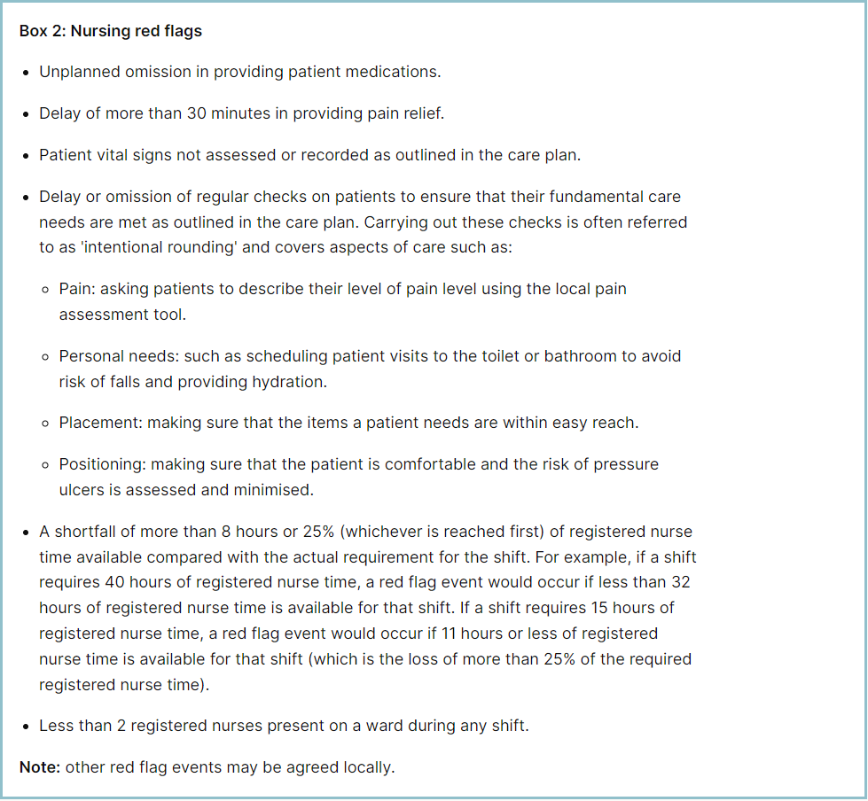

Appendix 4: Staffing Red Flags Trend Data

Appendix 5: Substantive staff redeployment trend

This reports looks at the number of shifts substantive staff working a shift are redployed, it does not include the shifts when agency, bank or multi post holders are redeployed.

Appendix 6: Falls Rate per 1000 bed days

Appendix 7: Total Pressure Ulcer Rate per 1000 bed days and Moderate Harm Pressure Ulcer Rate per 1000 bed days trend.

Appendix 8: Complaints, PALS and Compliments Trend Data

